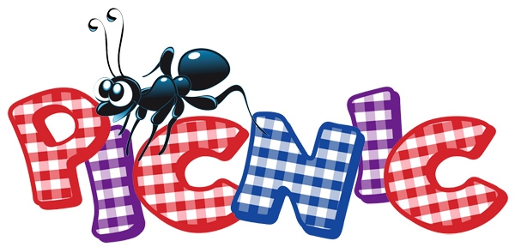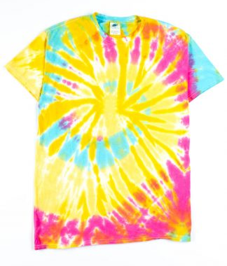

MP-East PBIS Picnic & Tie-Dye CELEBRATION
Friday, October 11th
Time: Afternoon
MP East School Yard
WEAR: old comfortable clothes/shoes

School Lunch will be SACK LUNCH (prepared by MP Cooks)
OR
YOUR CHILD MAY BRING A LUNCH FROM HOME.
***More information to come from your child’s teacher.***

We are excited to celebrate our student’s
success at being respectful, responsible
and safe at MP East Elementary!
Keep up the great work!

Go Golden Hawks!

